**“Experiment 3.2”**

Student Name: **SUMIT KUMAR** UID: **20BCS8226**

Branch: **CSE** Section/Group: **808-A**

Semester: **5** Date of Submission: **12-11-22**

Subject Name: **Design and Analysis of Algorithms Lab** Subject Code: **20CSP-312**

**AIM:**

# Code and analyze to find shortest paths in a graph with positive edge weights using Dijkstra’s algorithm.

# PROGRAM CODE:

#include <limits.h> #include <stdbool.h> #include <stdio.h>

#define V 9

int minDistance(int dist[], bool sptSet[])

{

int min = INT_MAX, min_index;

for (int v = 0; v < V; v++)

if (sptSet[v] == false && dist[v] <= min) min = dist[v], min_index = v;

return min_index;

}

void printSolution(int dist[])

{

printf("Vertex \t\t Distance from Source\n"); for (int i = 0; i < V; i++)

printf("%d \t\t\t\t %d\n", i, dist[i]);

}

void dijkstra(int graph[V][V], int src)

{

int dist[V]; bool sptSet[V];

for (int i = 0; i < V; i++)

dist[i] = INT_MAX, sptSet[i] = false;

dist[src] = 0;

for (int count = 0; count < V - 1; count++) {

int u = minDistance(dist, sptSet);

sptSet[u] = true

for (int v = 0; v < V; v++

if (!sptSet[v] && graph[u][v] && dist[u] != INT_MAX

&& dist[u] + graph[u][v] < dist[v])

dist[v] = dist[u] + graph[u][v];

}

printSolution(dist);

}

int main()

{

int graph[V][V] = { { 0, 4, 0, 0, 0, 0, 0, 8, 0 },

{ 4, 0, 8, 0, 0, 0, 0, 11, 0 },

{ 0, 8, 0, 7, 0, 4, 0, 0, 2 },

{ 0, 0, 7, 0, 9, 14, 0, 0, 0 },

{ 0, 0, 0, 9, 0, 10, 0, 0, 0 },

{ 0, 0, 4, 14, 10, 0, 2, 0, 0 },

{ 0, 0, 0, 0, 0, 2, 0, 1, 6 },

{ 8, 11, 0, 0, 0, 0, 1, 0, 7 },

{ 0, 0, 2, 0, 0, 0, 6, 7, 0 } };

dijkstra(graph, 0)

return 0;

}

# OUTPUT:

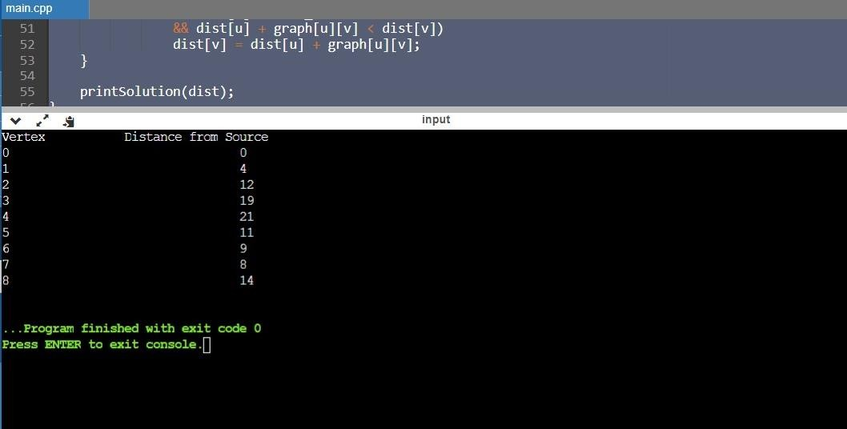

**Learning outcomes (What I have learnt):**

1. Learn about finding shortest path in the graph.
2. Learn about time complexity of program.
3. Learnt to implement Dijsktra’s algorithm using Prim’s algo.

**Evaluation Grid (To be created per the faculty's SOP and Assessment guidelines):**

|  |  |  |  |
| --- | --- | --- | --- |
| Sr. No. | Parameters | Marks Obtained | Maximum Marks |
| 1. | Worksheet completion including writing learning objectives/Outcomes.  (To be submitted at the end of the day). |  |  |
| 2. | Post-Lab Quiz Result. |  |  |
| 3. | Student Engagement in  Simulation/Demonstration/Performance and Controls/Pre-Lab Questions. |  |  |
|  | Signature of Faculty (with Date): | Total Marks Obtained: |  |